# Adjust Visualization

## Filtering

Check “set axis width and bin values based on axis below” to filter with user-inputs

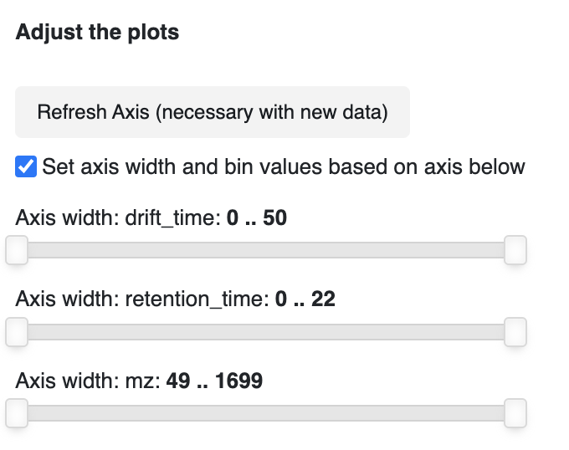

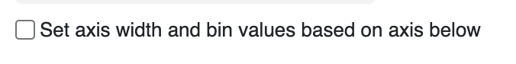

If the box isn’t checked, zooming is possible via the plot input “zoom”



Min spacing sets the minimum size of the grid during rasterizing

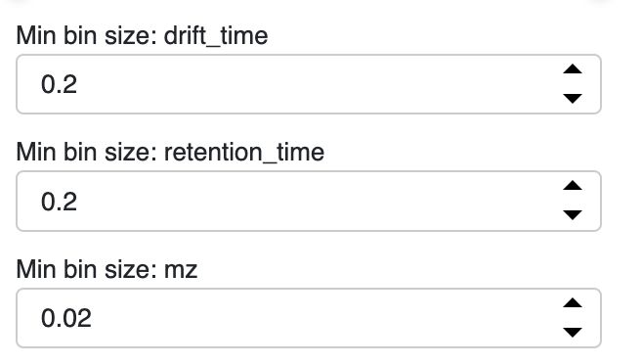

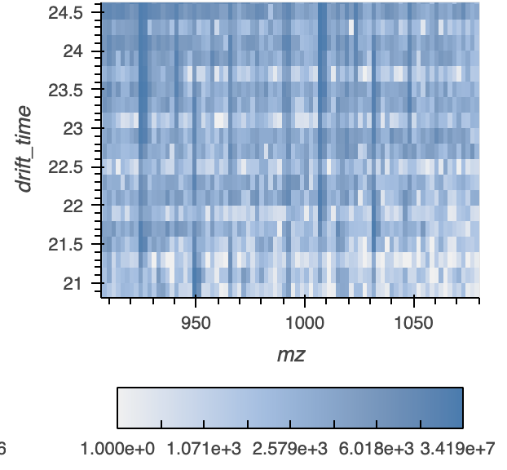

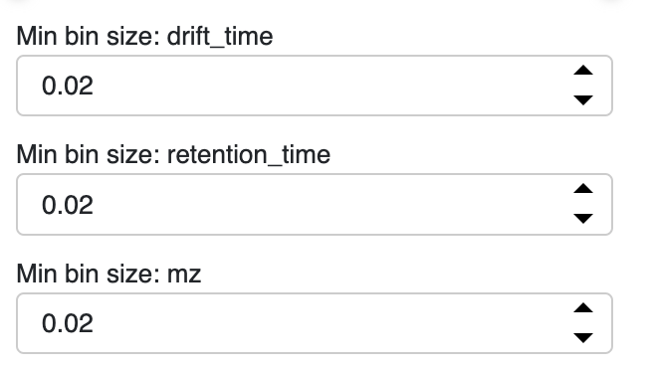

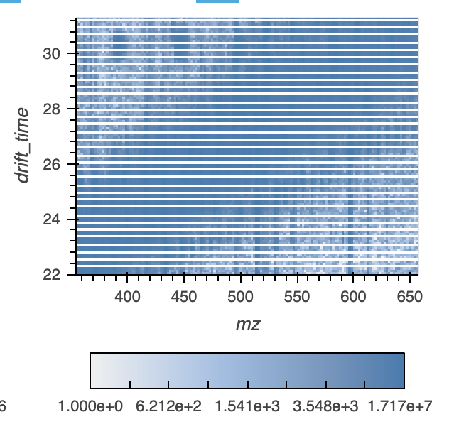

Due to quirk, <https://github.com/holoviz/holoviews/issues/5250>, sometimes the color-bar range doesn’t update on the zoom-in. The user can alter the bounds manually to trigger an update to the colorbar range

Linked Selection will filter on the underlying data, even if they aren’t used in the plot



# Column Name Selection

The names of the data can be updated here:

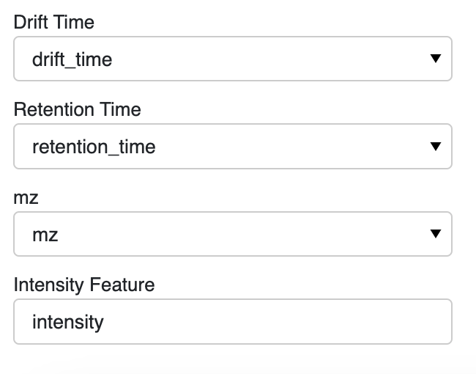

If the initial data is mzML, the user needs to select the names from the file to use as the retention and drift time

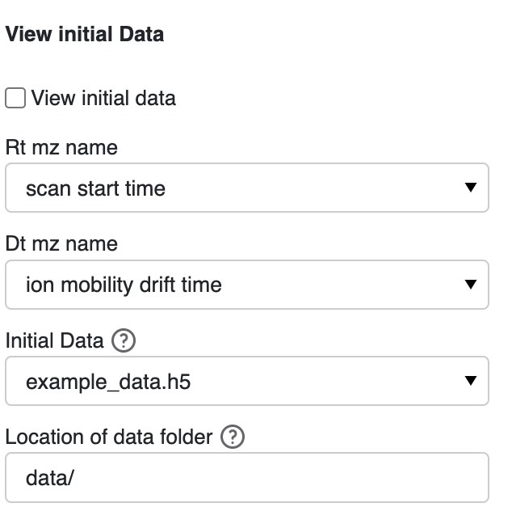

Select the files from the folder indicated in the “location of data folder” folder

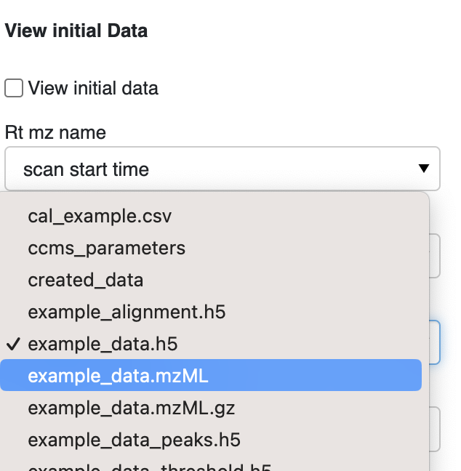

The original data is a placeholder Indicate the local path of the full data below to update. Use the box selector (as seen on the bottom) to filter data in all plots based on the box's range

# Smooth data:

The original data is a placeholder

Click 'Run smooth' after updating parameters to get new graph.

Keeping the smooth radius small and increasing number of iterations is preferable to a larger smoothing radius, albeit at greater computational expense

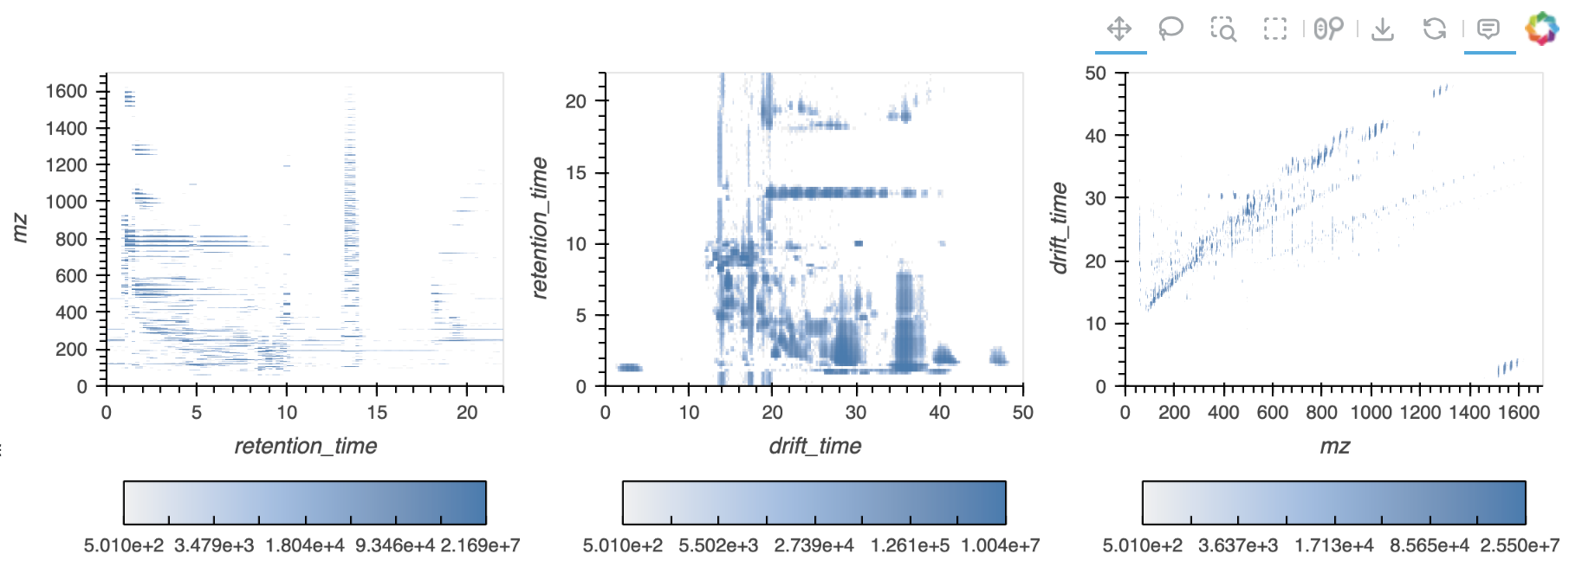

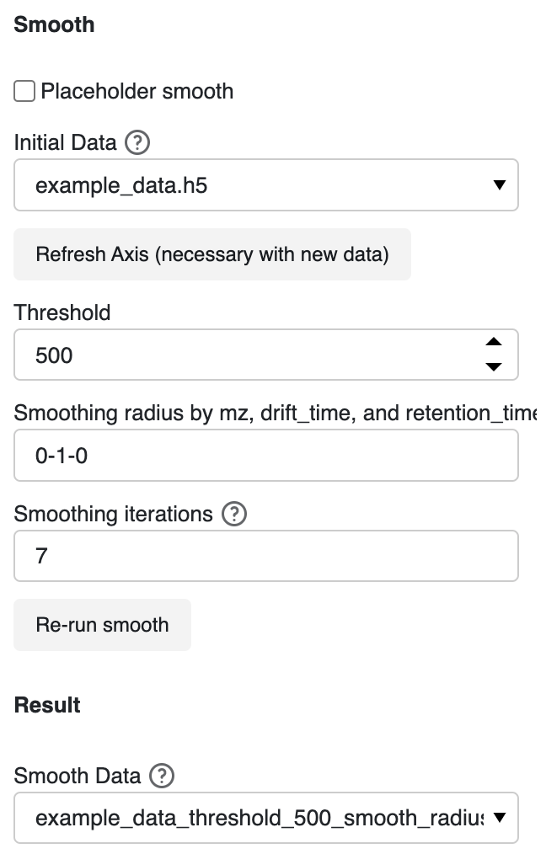

# Peak data:

Feature detection, also referred to as peak detection, is the process by which local maxima that fulfill certain criteria (such as sufficient signal-to-noise ratio) are located in the signal acquired by a given analytical instrument.

The original data is a placeholder

Click 'Run peak' after updating parameters to get new graph.

The radius per dimension insures an intensity-weighted per-dimension coordinate will be returned for each feature

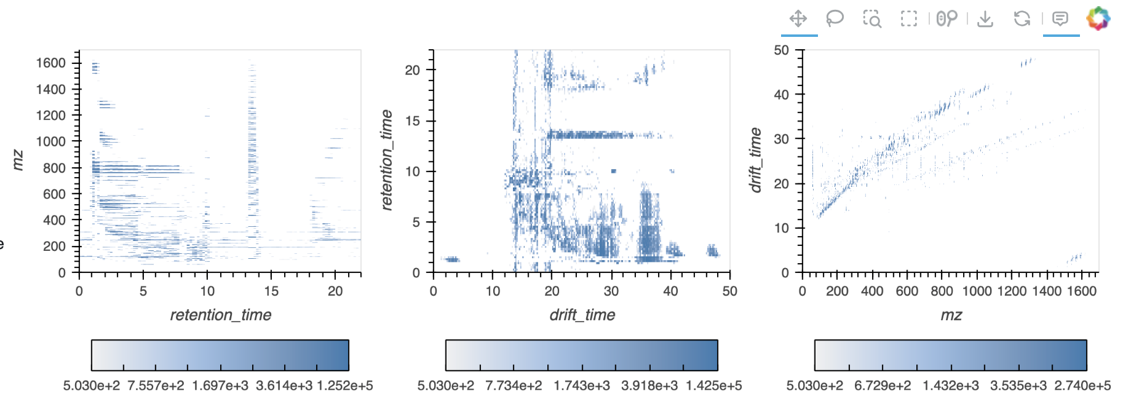

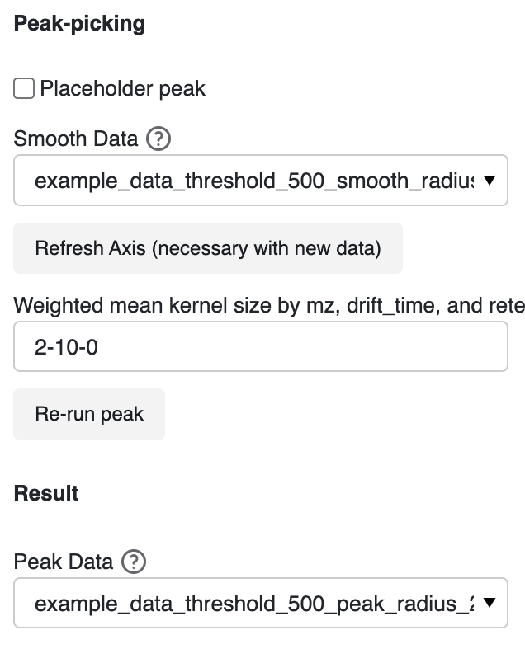

MS deconvolution

With MS1 features of interest determined by peak detection, corresponding tandem mass spectra, if available, must be extracted and assigned to the MS1 parent ion feature. The original data is a placeholder, clicking will not work without real data.

Click 'Run decon' after updating parameters to get new graph.

The MS2 data associated with user-selected MS1 data, with the MS1 data with the highest intensity used if there are multiple MS1 data points within a small range of the user-click

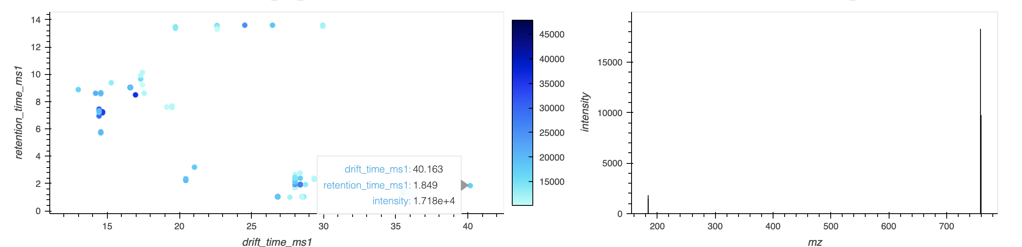

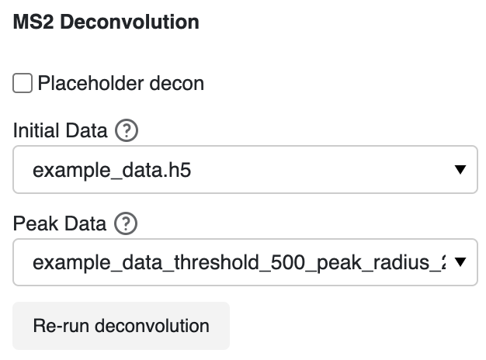

# Calibration

The calibrated file will be saved the “created data folder”. The data file must include zz, ccs, q, and, if not tune mix, a ta column.

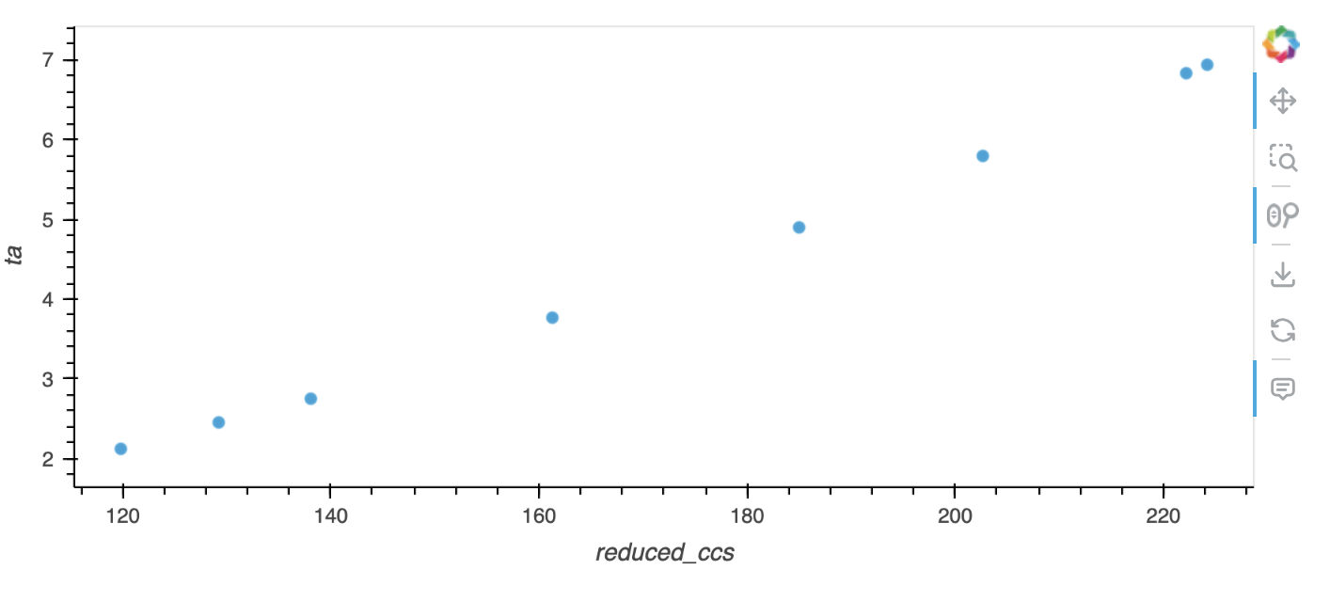

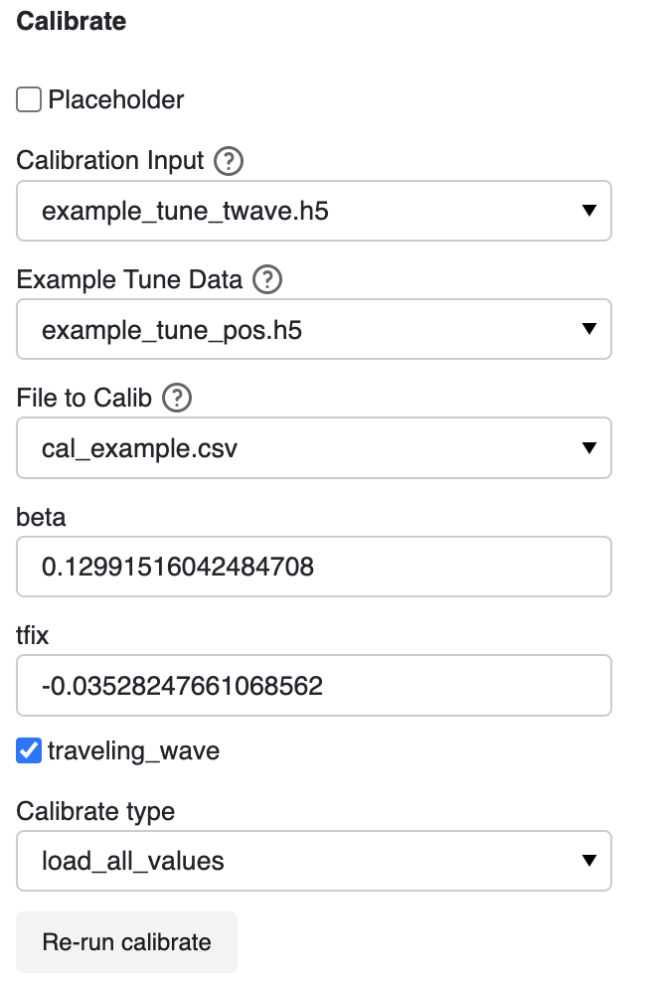

# Isotopes

Select a row in the dataframe to view the isotopes and a slice of the data around the isotopes

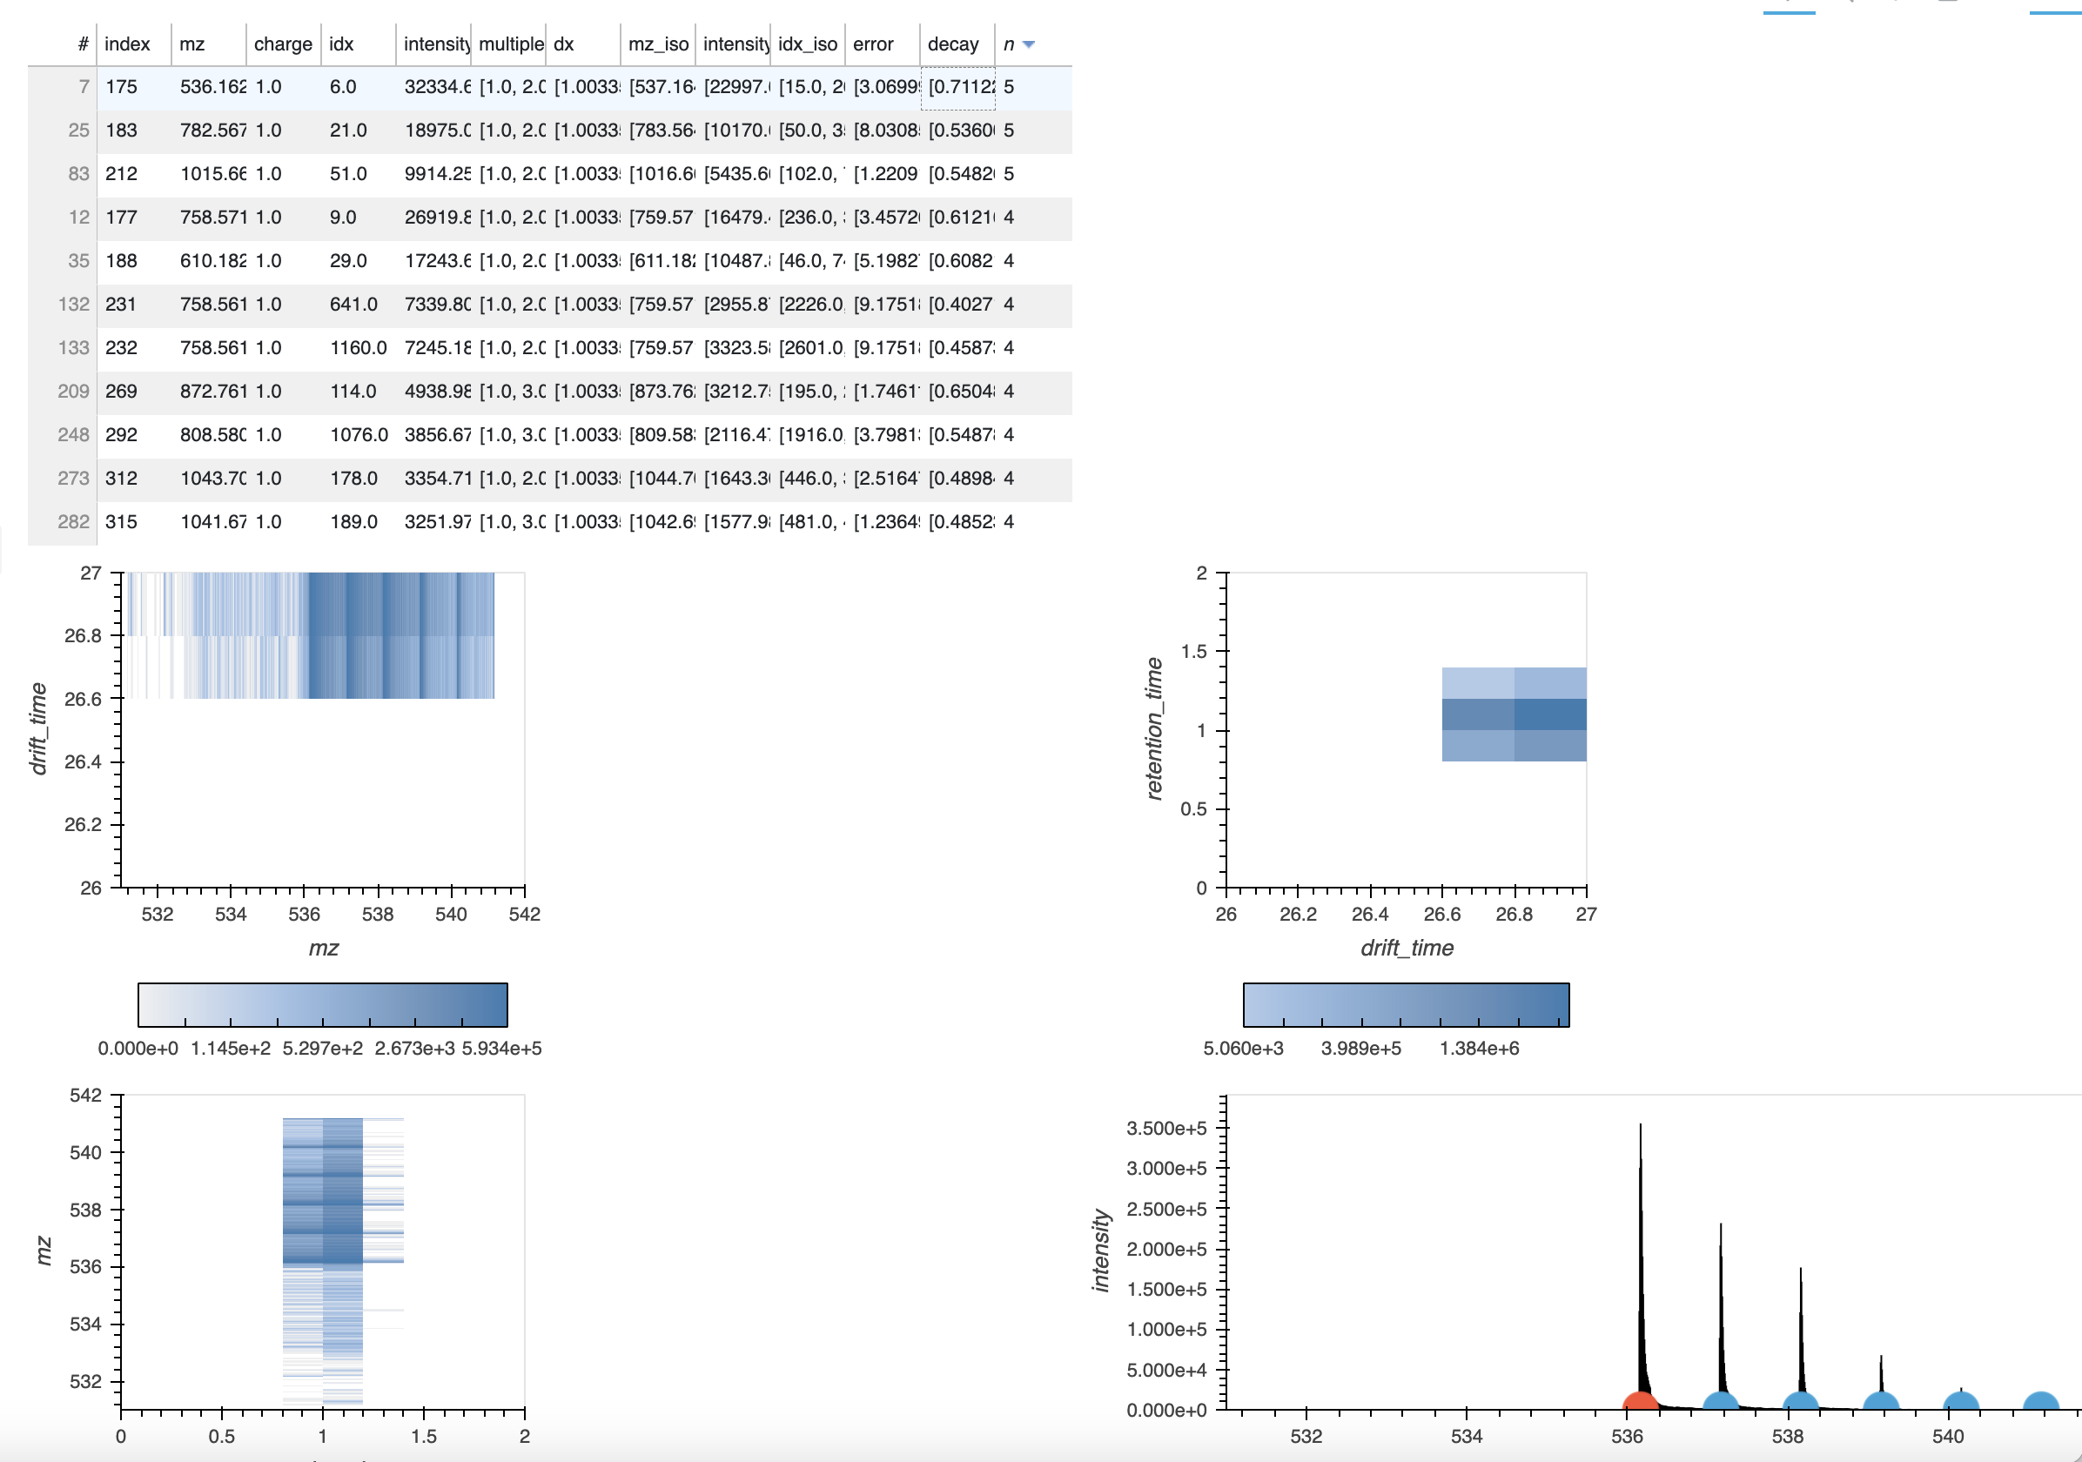



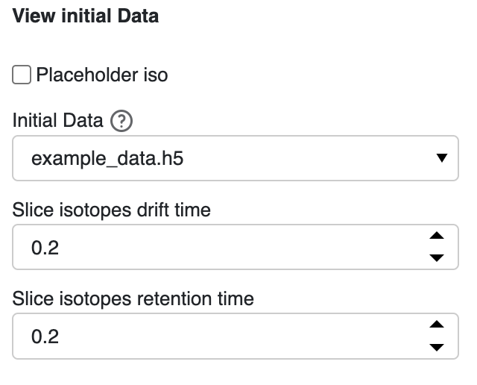

# Align

Update the peak folder location and indicate (with * as the wildcard) the ending of the files to use.

Alignment is the process by which feature coordinates across samples are adjusted to account for instrument variation such that matching features are aligned to adjust for small differences in coordinates

The original data is a placeholder

Indicate the reference file and folder of files to align.

Determine matches within tolerance per feature with the alignment determined by the kernel by relative or absolute value by support vector regression kernel.

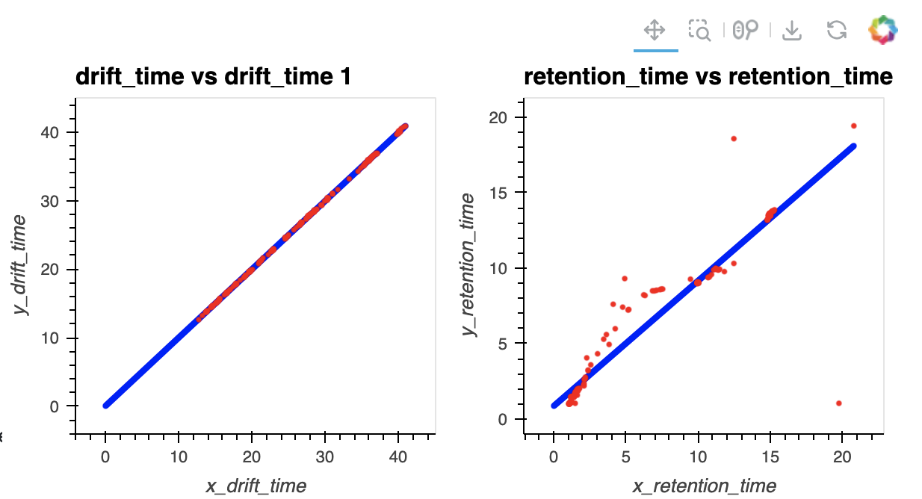

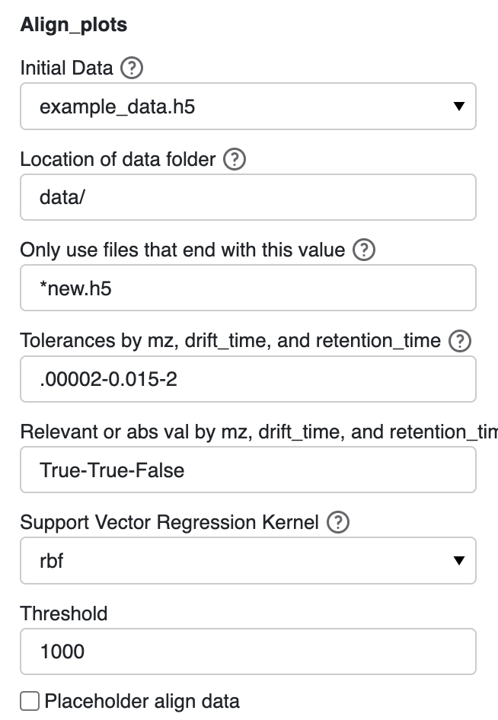

Extra:

“bokeh.core.serialization.DeserializationError: can't resolve reference warning” seem to occur when the align plots are updated. According to <https://discourse.bokeh.org/t/bug-with-deserializationerror-when-changing-content-layout-in-bokeh-3-1-1/10566> and <https://github.com/bokeh/bokeh/issues/13229>, it occurs when a layout is updated with new plots, and it is usually not something to be concerned about.